18/11/2024
DSA PRACTICE DAY 6
- BUBBLE SORT:
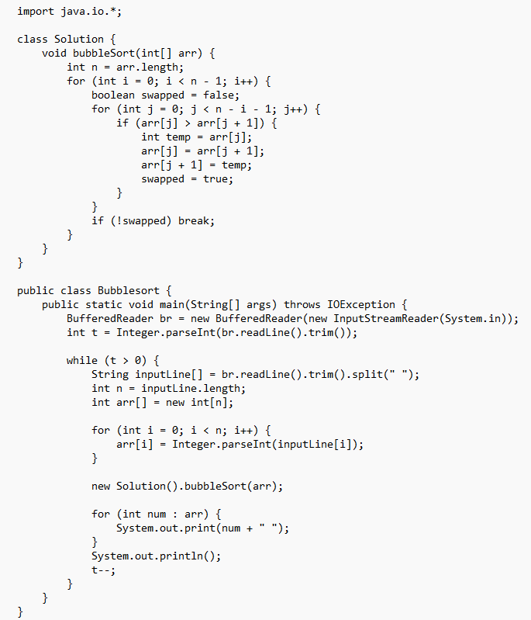

Output:
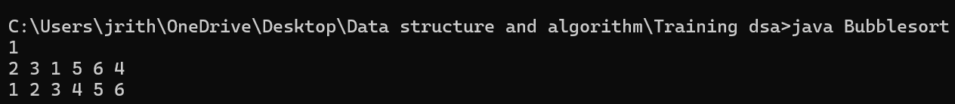
Time complexity:O(n^2)

- Quick sort
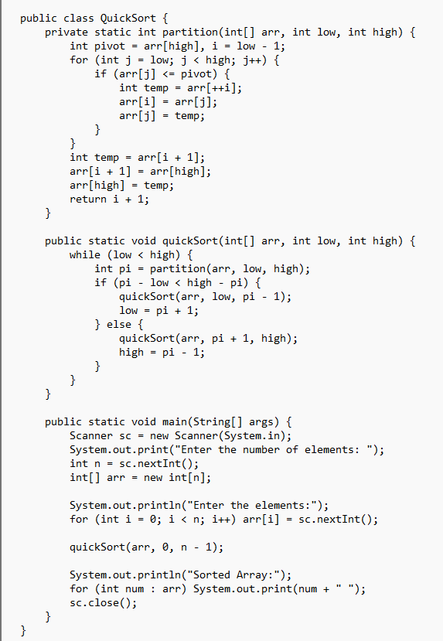
OUTPUT:
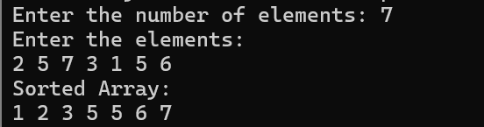
TIME COMPLEXITY: O(nlogn)

- NonRepeatingCharacter
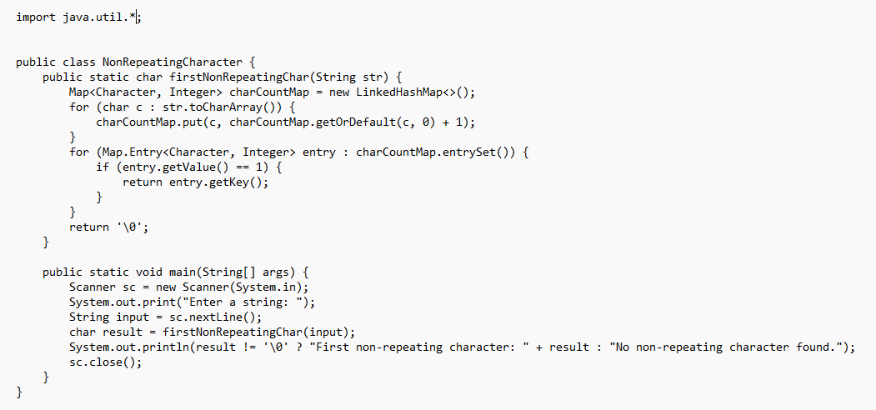
OUTPUT:
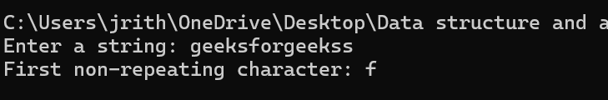
TIME COMPLEXITY: O(n)

- Edit the distance
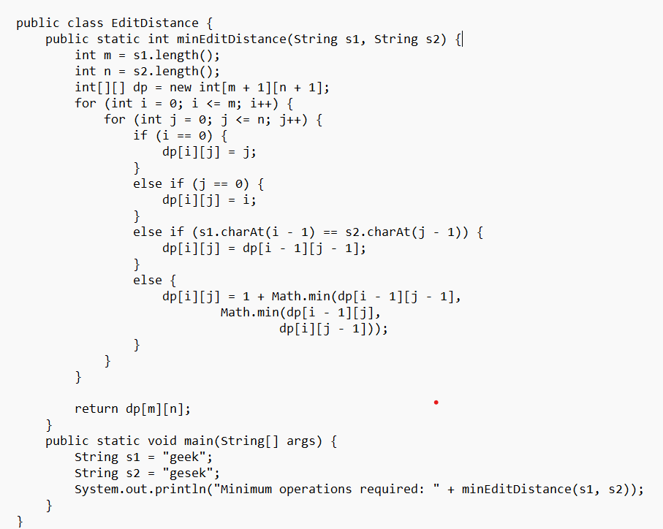

Output:
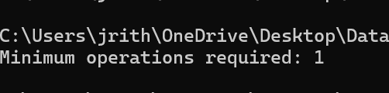

- KLargestElements
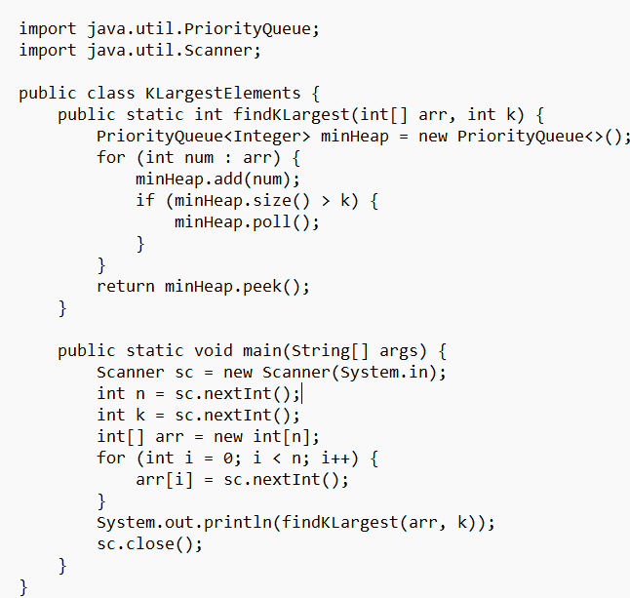

Output:
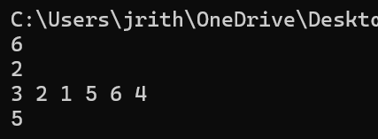

- Form the largest element
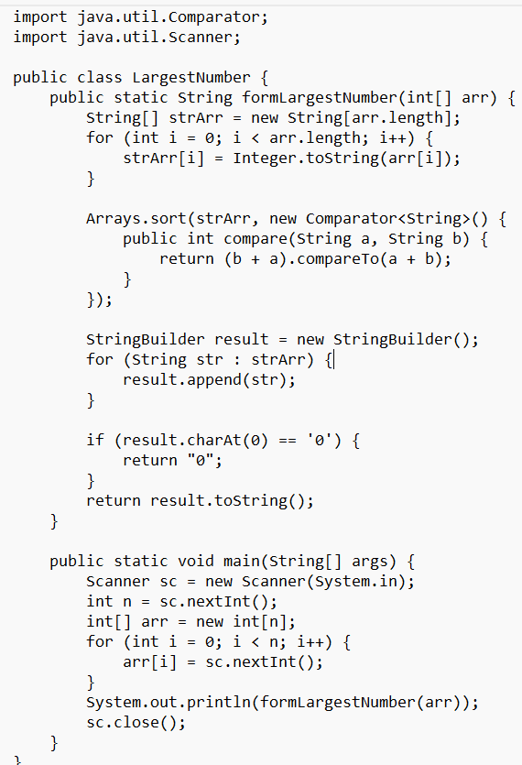

Output:
